Inner Joins

SELECT *

FROM orders

JOIN customers ON orders.customer_id = customers.customer_id

SELECT order_id, first_name, last_name

FROM orders

JOIN customers ON orders.customer_id = customers.customer_id

-- Simplify the table to only show the order id, first name, and last name columns

Simplify the code above using Aliases

SELECT order_id, o.customer_id, first_name, last_name

FROM orders o

JOIN customers c

ON o.customer_id = c.customer_id

**Exercise**

Write a query that joins the product id of order items table with products table returns product id and name

SELECT order_id, o.product_id, p.name, quantity, o.unit_price

FROM order_items o

JOIN products p

ON o.product_id = p.product_id

SELECT order_id, oi.product_id, quantity, oi.unit_price

FROM order_items oi

JOIN products p ON oi.product_id = p.product_id;

An inner join will show everything that is common within table A and table B. While querrying the INNER JOINS you will only see what is similar between both tables

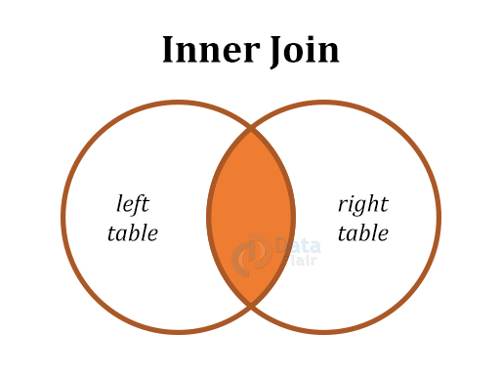

Full Outer Join will display all the data within both left and right tables whether it matches or not.

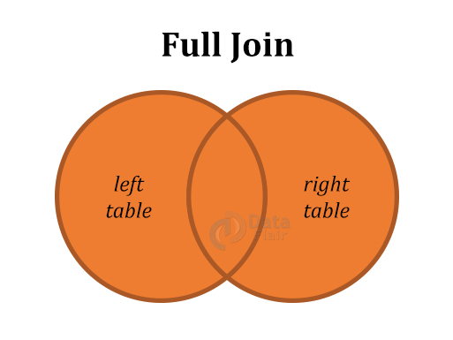

Left Join will display all the data both tables have in common but will also display only the data from left table even if the right is NULL(empty)

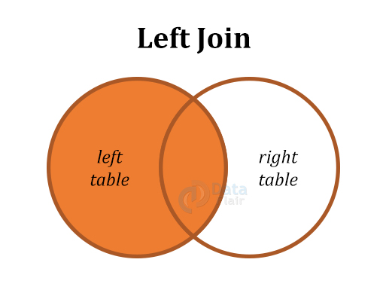

Right Join will display all the data form both tables that is common as well as the information on the right only even if it doesn’t have a match in the left table

